A comparative analysis of machine learning methods and building model for emotion recognition from EEG data

Prof. H. M. Oval
Professor in Computer Engineering,
MAEER’s MIT Polytechnic Pune, Maharashtra
mailto:hemaohal@gmail.com
Suyog Chavan
Diploma in Computer Engineering
MAEER’s MIT Polytechnic
Pune, Maharashtra
mailto:suyogschavan03@gmail.com
Rushikesh Shinde
Diploma in Computer Engineering
MAEER’s MIT Polytechnic
Pune, Maharashtra
mailto:rushikeshshinde956@gmail.com
Sanket Pophale
Diploma in Computer Engineering
MAEER’s MIT Polytechnic
Pune, Maharashtra mailto:sanketpophale77@gmail.com
Ritesh Shende
Diploma in Computer Engineering
MAEER’s MIT Polytechnic
Pune, Maharashtra
mailto:riteshshende616@gmail.com

Abstract—Emotion is the most important component in daily interaction among the people. Nowadays, it is important to make the computer systems recognize user’s emotion who interacts with it in human-computer interaction (HCI) systems. Electroencephalogram (EEG) signals are the primary supply of emotion in our body. Recently, emotion recognition primarily based totally on EEG signals have attracted many researchers and lots of methods have been reported. Different forms of features have been extracted from EEG signals then different types of classifiers have been implemented to those features. In this paper, a deep learning approach is proposed to recognize emotion from EEG signals. Long-Short Term Memory (LSTM) is used to learn features from EEG signals then the dense layer classifies those features into ‘negative’, ‘positive’, and ‘neutral’. The behavior of the human brain is extremely complex and difficult to decipher. Brain activity could be the source of human emotion. The link between human emotion and brain activity, on the other hand, is far from apparent. In recent years, an increasing number of researchers have attempted to establish this link by combining brain signals such as electroencephalogram (EEG) signals with emotion data derived from other modalities such as facial expression. Machine learning-based methods are employed in this paper to model this relationship in a publicly available dataset on Kaggle (EEG Brainwave Dataset).

Keywords—EEG, Emotion, Emotion Analysis, LSTM, RNN

INTRODUCTION
1.1 Introduction
Emotion is the most important component of being human, and very essential for everyday activities, such as the interaction between people, decision making, and learning. It eases the communication between people and makes it representative. It is important to detect and recognize the emotion in computer systems which people interact with, to enhance the communication between users and machines. Furthermore, we need to know the user's present status in order to improve the system's accuracy and throughput. In order to make the computer understand and recognize emotion, we need to understand the sources of them in our body. Emotions can be expressed vocally, such as through well-known words, or nonverbally, such as through voice tone, facial expression, and physiological changes in our neurological system. Voice and facial expression are not reliable indicators of emotion because they can either be fake by the user or may not be produced as a result of a specific emotion. Error: Reference source not found Because the user has no control over the physiological signals, they are more accurate. The fundamental origins of emotion in our bodies are physiological changes. Physiological alterations can be divided into two categories: those affecting the central nervous system (CNS) and those affecting the peripheral nervous system (PNS) (PNS). The central nervous system is made up of the brain and spinal cord. The brain is the control centre for everything in our bodies, and changes in electrical activity are translated into various behaviours and emotions. These electrical alterations are measured by an electroencephalogram (EEG). EEG is defined as alternating-type electrical activity picked up by metal electrodes and conductive medium and recorded from the scalp surface. EEG signals based on emotion detection will provide a correct emotion for usage in a variety of sectors. It can be used in automated healthcare applications, to assist people with autism in expressing their feelings, and to identify the learner's state in an E-learning system in order to create an adaptable E-learning system.
Emotion identification based on brain signals has the potential to revolutionize how we diagnose and treat certain diseases. Due to the limited number of facial expression triggers, dissembling of emotions, or among people with alexithymia, difficulties and restrictions may develop with general emotion identification software. The constant brainwaves generated by the human brain are used to identify such triggers. EEG (Electroencephalogram) data from the brain provide a richer picture of emotional emotions that are difficult to explain. EEG signals from the brain can reflect changes in electrical potential caused by communication networks between neurons. The epoch data from EEG sensor channels was analyzed, and multiple machine learning techniques [namely Support Vector Machine (SVM), RandomForest Classifier, Logistic Regression Classifier, Artificial Neural Network Classifier (ANN), and Extreme Gradient Boosting Classifier (XGBoost)] Dimensionality reduction was investigated with and without principal component analysis (PCA). Human brain waves have been classified according to different frequency collections: delta between 0.2 and 3Hz, theta between 3 and 8Hz, alpha between 8 and 12Hz, beta between 12 and 27Hz, and gamma more than 27 Hz.

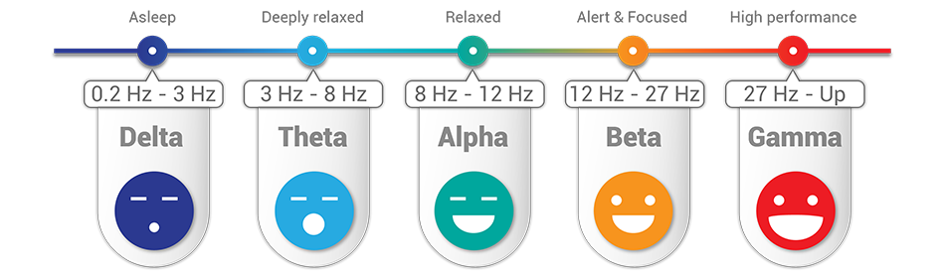
Figure 1. Classification of frequency from EEG

Each of these spectra is linked to a specific activity, such as moving limbs, sleeping, active thinking, or problem solving. EEG is utilized in brain-computer interfaces (BCI), which allow a human subject and a computer to communicate without making physical touch. Affective computing, which tries to understand the states of the human mind, is gaining prominence as a result of such studies [2]. Various EEG-based BCI paradigms are currently well-known [3].

1.2 Aim
This study intends to examine a range of traditional machine learning techniques based on p-value, minimum error, accuracy, precision, and f-score in order to improve performance with dimensionality reduction and extract hidden information. Artificial neural networks (ANN) and deep neural networks (DNN) outperform traditional machine learning algorithms in some applications, as they achieve higher accuracy. Tree different classes of positive, neutral, and negative were used to narrow down the degree of each sample.

Dataset

Experimental data
The dataset used in experiment is from Kaggle reference in [2] . Size of the Data : 45mb.
Data was collected for 3 minutes from two participants (1 male, 1 female) in each state - positive, neutral, and negative. A Muse EEG headband used which recorded the TP9, AF7, AF8 and TP10 EEG placements via dry electrodes. Six minutes of resting neutral data is also recorded, the stimuli [Figure 2] used to evoke the emotions are below.

- Marley and Me - Negative (Twentieth Century Fox)
Death Scene
- Up - Negative (Walt Disney Pictures)
Opening Death Scene
- My Girl - Negative (Imagine Entertainment)
Funeral Scene
- La La Land - Positive (Summit Entertainment)
Opening musical number
- Slow Life - Positive (BioQuest Studios)
Nature timelapse
- Funny Dogs - Positive (MashupZone)
Funny dog clips

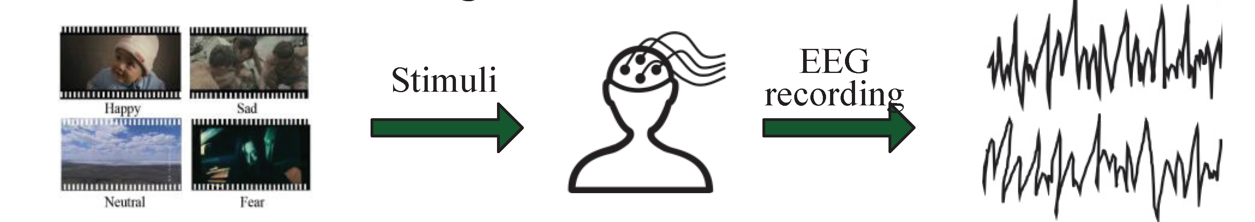
Figure 2. Dataset Creation
Source of Film clips were employed as EEG stimulation. For EEG Brainwave Data Collection [Table I.]

Table I. Film clips were employed as EEG stimulation.
Stimulus | Valence | Studio | Year
Marley and Me | Neg | Twentieth Century Fox, etc. | 2008
UP | Neg | Walt Disney Pictures, etc. | 2009
My Girl | Neg | Imagine Entertainment, etc. | 2016
La La Land | Pos | Summit Entertainment, etc. | 2016
Slow Life | Pos | BioQuest Studios | 2014
Funny Dogs | Pos | Mashup Zone | 2015

On the international standard EEG positioning system, the Muse headband's EEG sensors TP9, AF7, AF8, and TP10:
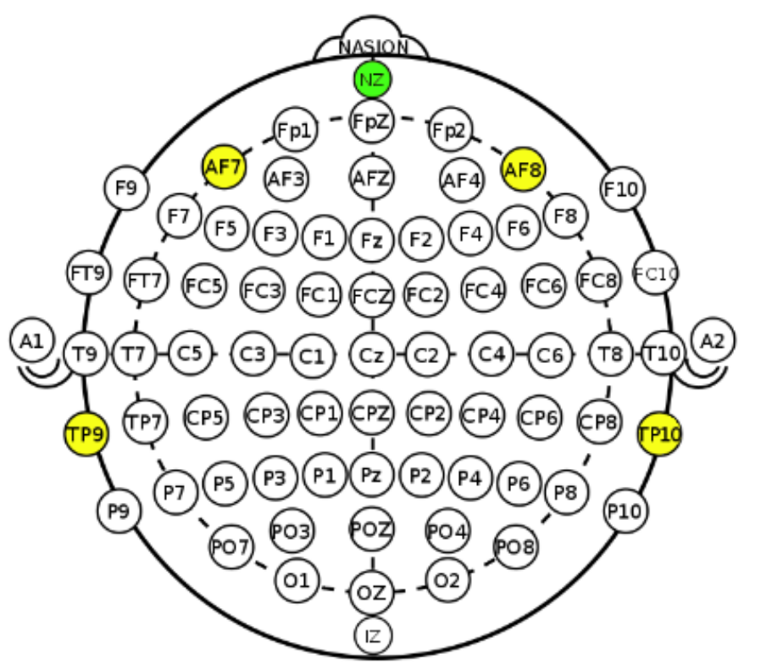
Figure. 3. International 1020 EEG placement system

Proposed Methodology
In this paper, end-to-end deep learning neural network is applied to raw EEG signals of 2 participants who watched the 6 videos, in order to recognize the emotion elicited from these videos. Each video segmented into 2 segments with a length of 5 seconds. Three different classification problems were posed: Negative, Neutral, and Positive. Since there are two levels only per each classification problem, then the continuous rating range per class is thresholder in the middle such that if the rating is greater than or equal to five then the video/trail belongs to high class otherwise, it belongs to the low class.

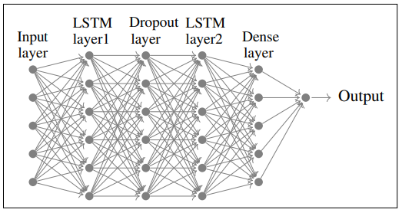
Figure. 3. Deep Learning Neural Network Model

Fig. 4 shows the proposed deep learning neural network model. It is made up of two LSTM layers that are fully coupled, a dropout layer, and a dense layer. The dropout layer used to reduce the Overfitting by preventing units from co-adapting too much. The LSTM and dropout layers are used to learn features from raw EEG signals and the dense layer is used for classification.

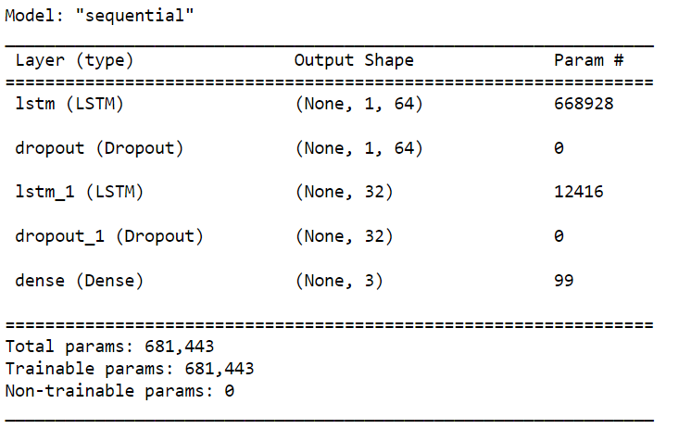
Figure. 5. Detailed Proposed Mode

Recurrent neural networks with Long Short-Term Memory Networks (LSTMs) are a type of recurrent neural network (RNN). Hochreiter and Schmidhuber introduced it in 1997 [3] to solve the problem of long-term reliance in RNNs. Long sequences are challenging to learn with a standard RNN since it is trained using back-propagation through time (BPTT), which results in vanishing/exploding gradients. To solve this problem, the RNN cell is replaced by a gated cell, such as an LSTM cell. The basic construction of an LSTM cell is shown in [Fig.3].
These gates control which information must be remembered in memory and which are not. The memory provided to the LSTM cell allows it to recall earlier steps. The key to LSTMs is the cell state (the horizontal line on the top of figure 1 (Ct)). LSTM has the ability to remove or add information to the cell state by using three gates. The first gate is a forget gate to decide what information to throw away from the cell state, this decision made by a sigmoid layer
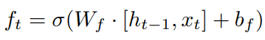
Equation 1
The second gate is an input gate that consists of a sigmoid layer that determines which values will be updated and a tanh layer that generates a vector of new updated values as specified in (Equation 2) and (Equation 3).
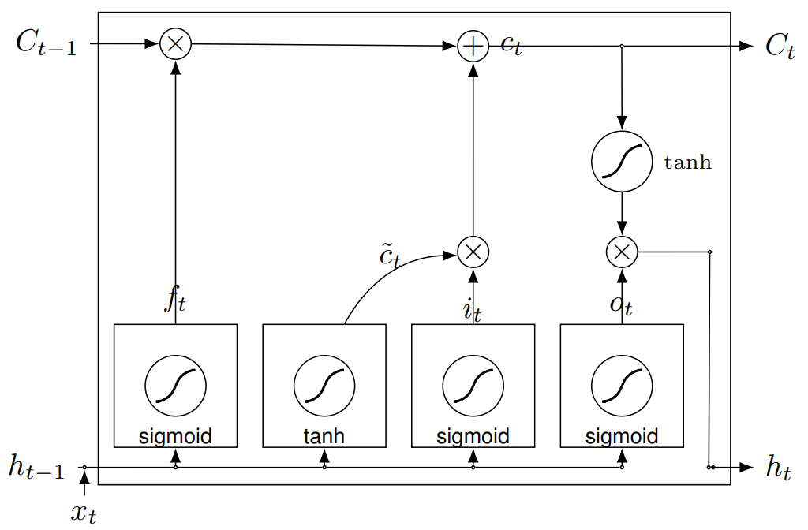
Figure 6. Basic Construction of LSTM Cells

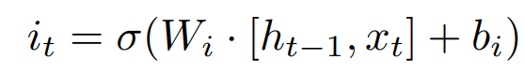
Equation 2
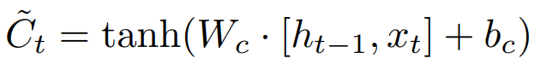
Equation 3

The cell state was then updated using equations 1, 2, and 3 as follows:
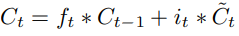
Equation 4

Finally, using the updated cell state and a sigmoid layer that determines which parts of the cell state will be the final output as indicated in equations 5 and 6, the output of the current state will be determined.
Equation 5

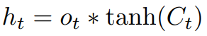
Equation 6

where σ is sigmoid activation function which squashes numbers into the range (0,1), tanh is hyperbolic tangent activation function which squashes numbers into the range(-1,1), W_{f} , W_{i} , W_{c}, W_{o} are the weight matrices, x_{t} is the input vector, h_{t−1} denote the past hidden state and b_{f}, b_{i}, b_{c}, b_{o} are bias vectors.

Other Classifiers
4.1 RandomForest Classifier
RandomForest is an ensemble classifier that uses a tree and bagging approach. Its probabilistic entropy calculation approach will automatically reduce the amount of characteristics.
Accuracy for RandomForest : 0.9868742047299373
Wall time: 28.4 s

4.2 Logistic Regression Classifier
The same as linear regression, logistic regression is a linear classifier.
Accuracy for Logistic Regression: 0.9324667631959983
Wall time: 2min 22s

4.3 Artifical Neural Network (ANN)
With dynamic feature engineering and dimensional reduction approaches, an ANN classifier becomes non-linear. MLPClassifier is an ANN in scikit-learn. However, fundamental data scaling is required here as well.
Accuracy for ANN : 0.9765360422266959
CPU times: user 27min 34s, sys: 12min 55s, total: 41min 35s
Wall time: 12min 11s

4.4 Linear Support Vector Machines Classifier (SVM)
Accuracy for Linear SVM : 0.9643467083227542
CPU times: user 1min 35s, sys: 4.41 s, total: 1min 39s
Wall time: 1min 36s

4.5 Extreme Gradient Boosting Classifier (XGBoost)
XGBoost is an ensemble classifier based on boosted trees. It will, like 'RandomForest,' automatically shrink the feature set.
Accuracy for XGBoost Classifier : 0.9943615599489364
CPU times: user 14min 12s, sys: 2.44 s, total: 14min 14s
Wall time: 14min 14s
Following table shows Accuracy and walltime of each classifier [Table II.].

Table II. Film clips were employed as EEG stimulation.
Classifier | Accuracy | WallTime
RandomForest | Approx. 98% | 28.4s
Logistic Regression | Approx. 93% | 2min 22s
ANN | Approx. 97% | 12min 11s
SVM | Approx. 96% | 1min 36s
XGBoost | Approx. 99% | 14min 14s

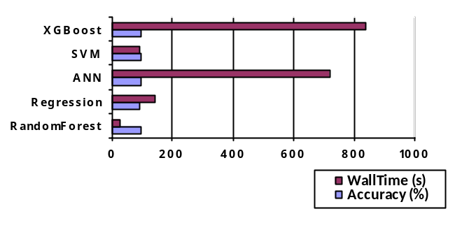
Figure 7. Wall Time vs Accuracy of Classifiers

Results
The model is trained on 50% of the videos using 4 cross - validation and tested on 50% of them. 100 epochs used for each cross - validation iteration. Keras library with TensorFlow backend is used to implement the proposed deep learning method and Matplotlib is used to plot the output. Output Plotted below:

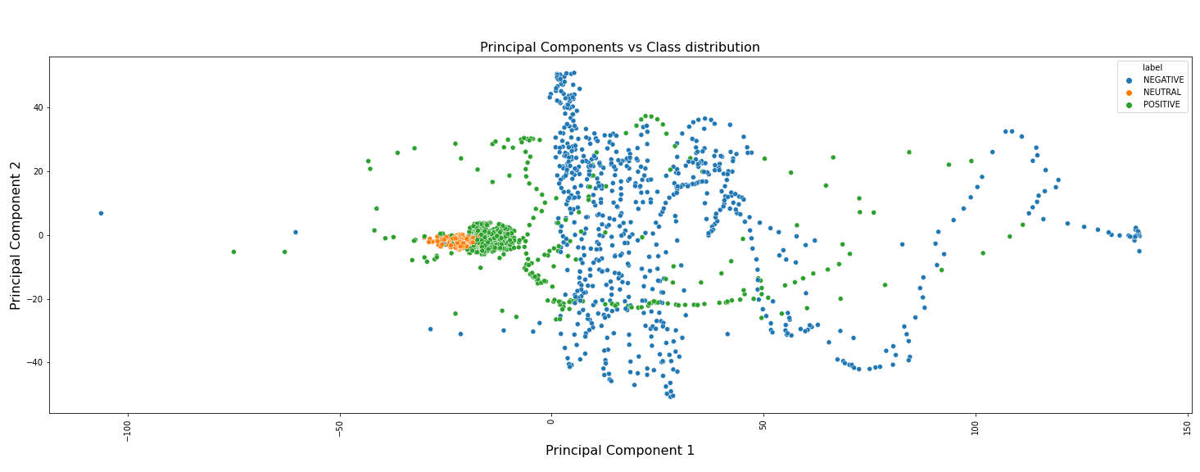
Figure. 8. Principal Component vs Class distribution

Model Report:
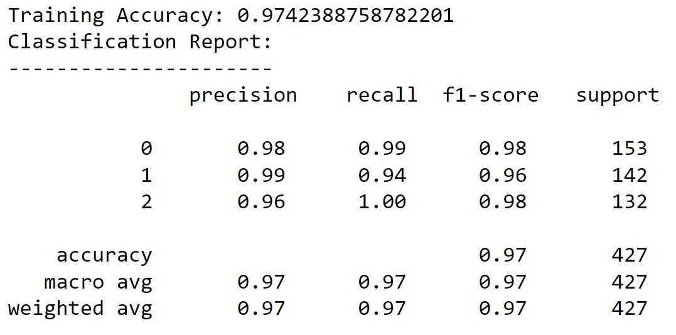
Figure. 9. Model Report

Confusion Matrix of Model
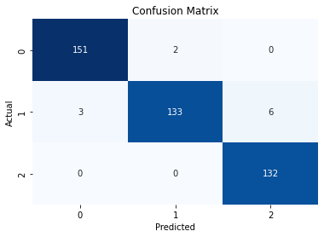
Figure. 9. Confusion Matrix of Model

We have got 416 correct Predicted emotion stages out of 427

Conclusion
This paper presents the comparative analysis and study of different classifiers mainly used in EEG data analysis. Generated a LSTM (RNN) based model to classify and predict human emotion in Neutral, Negative and Positive classes.

REFERENCES

- TheSai.org, 25 October 2017 (Emotion Recognition based on EEG using LSTM Recurrent Neural Network)
- Dataset-EEG Brainwave Dataset: Feeling Emotions
- Reserchgate.net, 2 August 2021, (Mental Emotional Sentiment Classification with an EEG-based Brain-machine Interface)
- Reserchgate.net, 18 August 2019, (A Deep Evolutionary Approach to Bioinspired Classifier Optimisation for Brain-Machine Interaction)
- Sciencedirect, December 2021, (Emotion recognition based on EEG feature maps through deep learning network)
- IEEE Xplore, 28 January 2016 ( Enhanced three-dimensional visualization of EEG signals )
- IEEE Xplore, 04 November 2013 (Classification and visualization for EEG data )
- IEEE Xplore, 09 February 2017 (Enhanced visualizations for improved real-time EEG monitoring)
- IEEE Xplore, 22 June 2021 (Emotion Recognition From EEG Signal Focusing on Deep Learning and Shallow Learning Techniques)
- IEEE Xplore, 14 November 2019 (A Survey on Emotion Recognition from EEG Signals: Approaches, Techniques & Challenges)
- IEEE Xplore, 15 July 2019 (Interpretable Emotion Recognition Using EEG Signals)

 

